***REDCap Data Collection***

REDCap will take the place of the manual data collection tool data entry as well as the need for Filezilla sftp connection. This reference guide is intended to provide users with a step-by-step instruction of acquiring access to REDCap and all related applications/authenticators to continue data collection for the RETAINWORKS grant.

IF YOU ALREADY HAVE KUMC AFFILIATE LOGIN, PLEASE PROCEED TO SECTION C1 BELOW.

1. ***Requesting Credentials to KUMC Affiliate***

RETAINWORKS administrators will provide your work emails to KUMC for generation of credentials to the KUMC Affiliate site. Following this request, users will receive an email from KUMC Affiliate in which users will follow the direction below:

**Step 1: Establish Password for KUMC Affiliate Account (One-Time Set-up)**

University of Kansas Medical Center (KUMC) network will provide your KUMC Affiliate username via message to your work email. This email should come from [AccountManagement@kumc.edu](mailto:AccountManagement@kumc.edu).

1. Create initial password as prompted by KUMC network
2. Ensure password meets the proper criteria
3. Login to KUMC Network as indicated in section C below
4. Provide assigned username back to Shelly Jones at [shelly.jones@ks.gov](mailto:shelly.jones@ks.gov) for REDCap account creation request

**Step 2: Maintaining Updated Passwords (Ongoing)**

University of Kansas Medical Center (KUMC) network account password expiration message will be sent to your work email from [AccountManagement@kumc.edu](mailto:AccountManagement@kumc.edu) In order to retain your level of access to KUMC and Hospital enterprise systems, you will need to complete the following steps:

1. Open your web browser and go to password.kumc.edu.
2. Log in with your current credentials
3. If you have not set “Security Questions”, you will be required to set them. These questions will allow you to change your password in password.kumc.edu if you have forgotten your password.
4. Select the "Change your current password" option to update your password

*NOTE:* If you are logged into your KUMC account on other workstations or devices, please logout prior to changing your password. If you have a Mobile device that accesses your Exchange email account or a KUMC wireless network, you will need to make sure that you update your password on that device to your new password.

For technical assistance, please contact Customer Support at 913-945-9999 then press 2 with any questions or issues related to changing your password.

1. ***Connecting to Duo Mobile (One-Time Set-up)***

RETAINWORKS REDCap system requires a secondary authentication process in order to verify credentials and enter the application. The following instructions will be a one-time occurrence unless your mobile device is updated between now and the end of the grant. *NOTE:* If you are a Commerce user and plan to utilize a Commerce issued cell phone for your authentication application, you will need to follow additional instructions for connecting to the Commerce portal within the phone prior to downloading the application.

**Step 1: Go to App Store**

1. Go to the App Store on your mobile device.
2. Search for Duo Mobile application



1. Select “Install”
2. Once the application has installed, select “Open”

**Step 2: Link REDCap Credentials to the Duo Mobile Authenticator**

1. Click on the “Add” button 
2. Next, you have the option to “Use QR Code” or you can search for the application you are authenticating.
3. QR Code is a more direct route, however, to search use University of Kansas Medical Center. KU Medical Center will be listed in your accounts once you connect successfully:

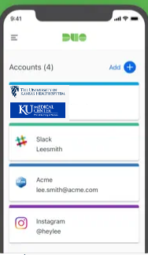

*Additional Resource on Duo Mobile connections can be found at the following link:*

<https://sokansas-my.sharepoint.com/:f:/g/personal/shelly_jones_kdc_ks_gov/EhGfgwVPEPVKkteQOBW2GYUBEPrkVufDv-VzzGKqI-MyeA?e=ZeehPf>

1. ***University of Kansas Medical Center Login***

REDCap system works in unison with the University of Kansas Medical Center systems based on a project assignment capacity. Therefore, all users for the purposes of collecting RETAINWORKS data in the REDCap system must have a University of Kansas Medical Center approved credential to enter the REDCAP system. Instructions for gaining credentials are found in section A above. Following the receipt of credentials, to connect to the KUMC Affiliate network, follow the steps below:

**Step 1: Connecting to KUMC REDCap Project**

1. Go to the KUMC link shown here: <https://redcap.kumc.edu/index.php?user_verify=4kL3PKzirtVhmE724C77>
2. When redirected to the “InCommon” page, select from the drop down, University of Kansas Medical Center
3. Click “Select”

***WARNING: PLEASE DO NOT SELECT ANY OTHER HOME ORGANIZATION OTHER THAN UNIVERSITY OF KANSAS MEDICAL CENTER! CHANGING FROM AN ORGANIZATION OTHER THAN THIS ONE IS DIFFICULT WITHIN THE INCOMMON ENVIRONMENT!***

**Step 2: Connecting to REDCap**

1. At the Central Authentication Services Login page (shown below), enter your Userid and Password
2. Click “Login”

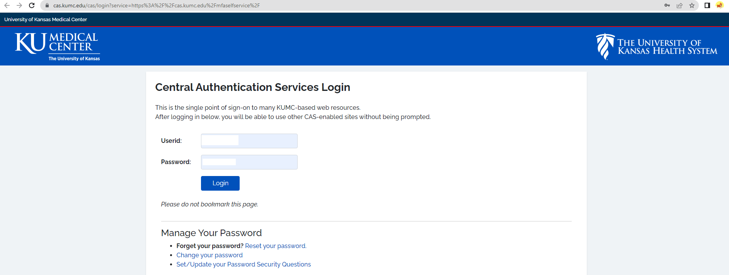

**Step 3: Providing Authentication (Duo Mobile)**

1. Users will be redirected to a connection window, which indicates the system is attempting to gain authentication through Duo Mobile (See section B above for set-up on your mobile device)
2. You have two options for authentication, “Send Me a Push” or “Enter a Passcode” (shown below).

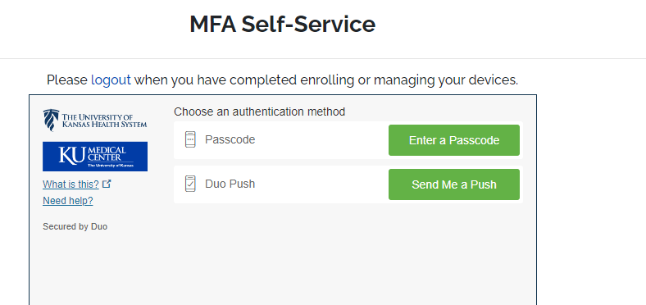

1. Open Duo Mobile application on your mobile device.
2. By clicking on “Send Me a Push”, your Duo Mobile application will require you to swipe to “Approve” on your mobile device, which will redirect you to the REDCap Project Home page:

1. If you selected “Enter a Passcode” or “Other Options”, you will then need to retrieve the 6-digit code from the Duo Mobile application on your mobile device.

1. Go to you Duo Mobile Application on your mobile device.
2. Click “Refresh passcode”
3. Enter the code displayed on the KUMC authentication page in the passcode field (shown below).
4. Click “Log In”

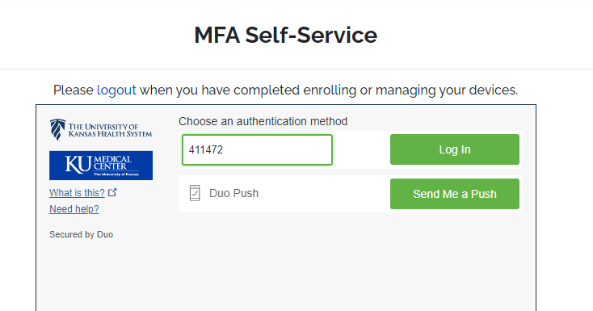

*NOTE:* Users can add more than one device to implement the multi-factor authentication, however, the application must be Duo Mobile on all devices (personal or work related).

1. Users should be successfully connected to the REDCap Project Home Page.
2. ***Navigating REDCap***

**Step 1: Accessing RETAINWORKS Project in REDCap**

Once authentication is complete, users will be redirected to the REDCap Home Page powered by KU Medical Center and the University of Kansas show below:

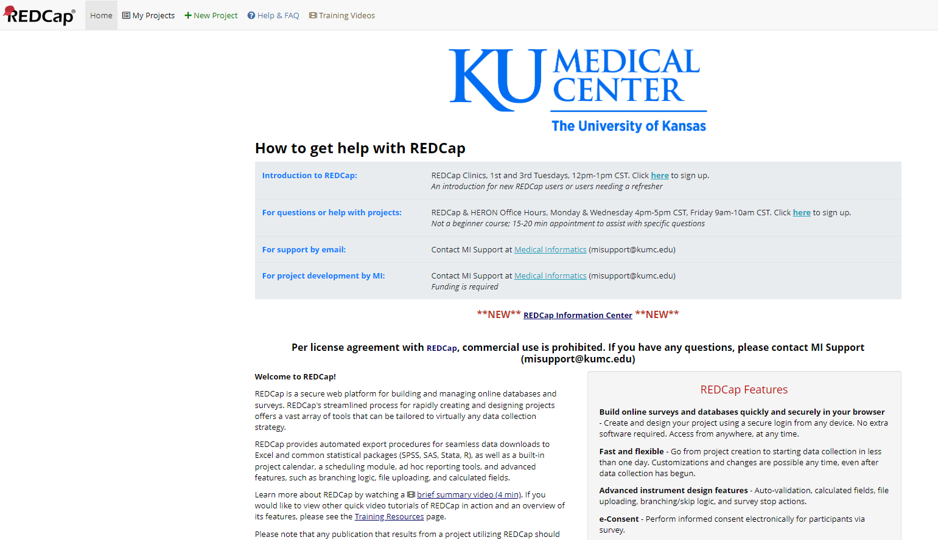

1. Click on the  option at the top left of the home page:



1. Scroll to the My Projects list and select RETAINWORKS Clinical Data Repository to Support the Retaining Employment and Talen injury/illness Network (RETAIN) Demonstration Project of the Kansas Department of Commerce (KDC):

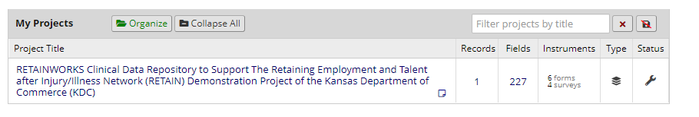

1. Users will be redirected to the RETAINWORKS project home page, shown below:

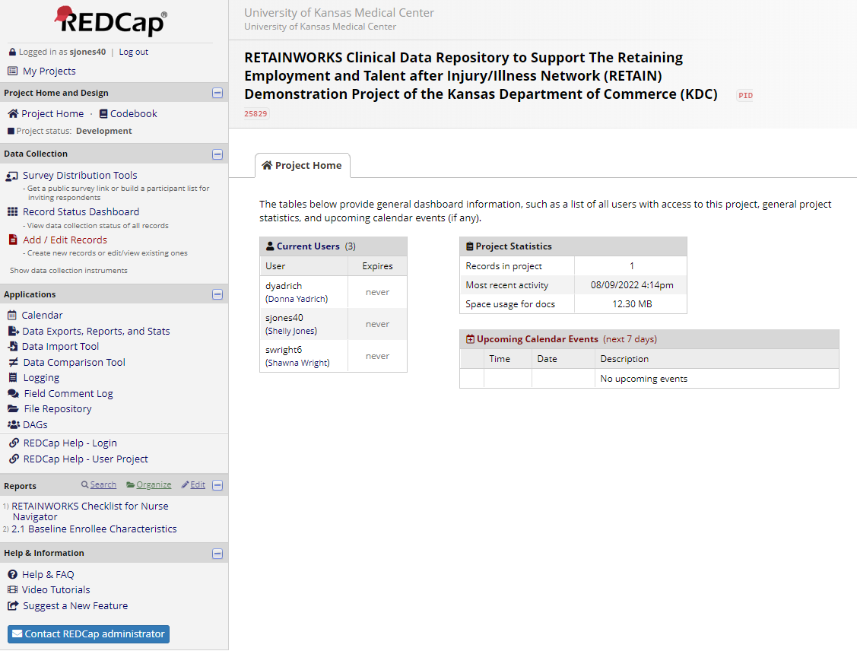

At the RETAIN home page, the left is the navigation bar leading to a variety of activities.

**Step 2: Adding a New Participant/Patient**

1. From the left menu, data collection section, select :

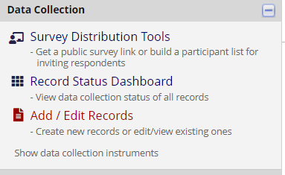

1. At the Add / Edit Records page, click on the green button .
2. At the Record Home page, notice sections are labeled to align with the Appendix A and more specifically the Manual Data Collection Tool:

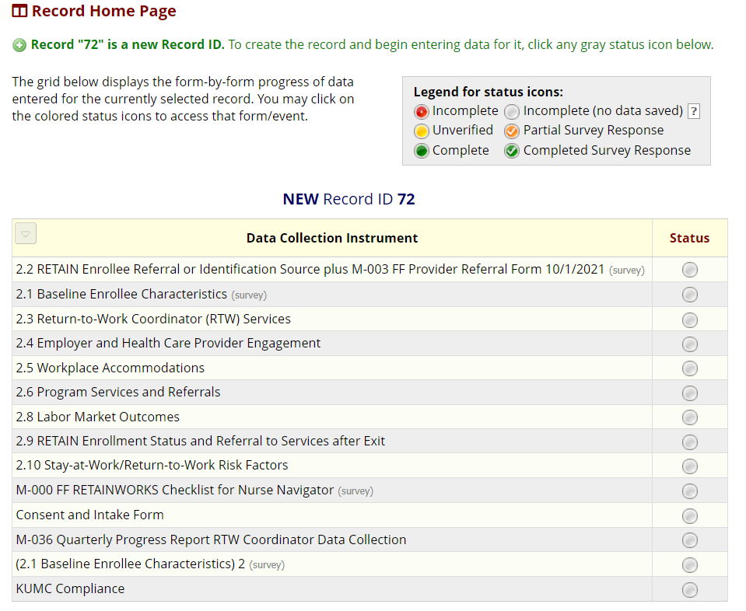

1. Click on the status button for the section to begin to enter data entry. 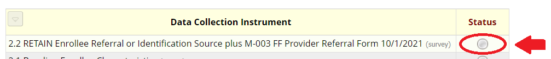

*NOTE:* You may or may not be able to progress in sequential order with data entry. For example, if you are entering baseline information, you would begin with 2.1, however, if you are entering workplace accommodations, you may want to begin with 2.5 within the REDCap forms.

1. Users will be redirected to the corresponding form of which the status button was selected, similar to the below:

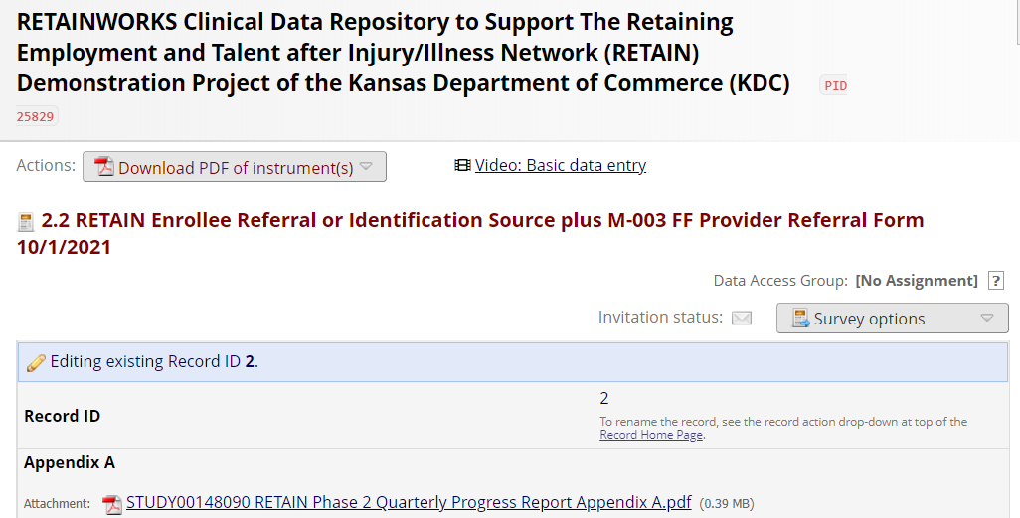

Once data is entered, the status will update and will indicate if the section has been completed or is incomplete, etc. See the legend shown above the Data Collection Instrument section, similar to the below:

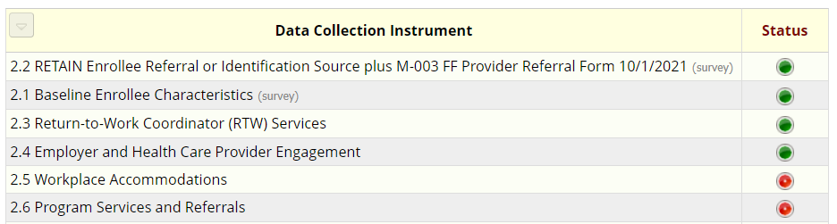

1. 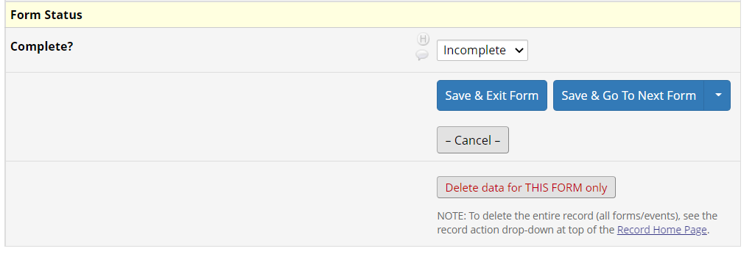As users progress thru the sectioned pages, users will save and exit form or save and go to next form until complete.

At anytime during data entry, users can also utilize the Save & Exit Form and Save & Go To Next Form buttons at the top right of the page:

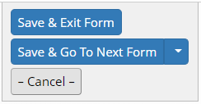

1. To navigate to other sections within a records form, see the links located at the left of a form. These links will allow the user to move between forms within a record:

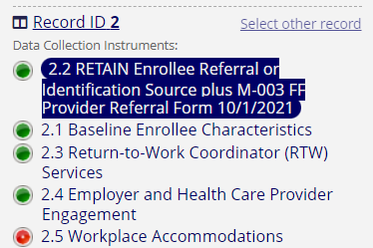

1. Each record will begin with the 2.2 section with accessing the instruments for referral to include the Referral or Identification Source plus M-003 FF Provider Referral Form 10/1/21. This form is available within the project records as shown below:



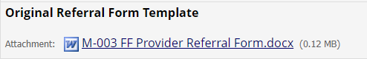

*NOTE:* REDCap shows required fields by a red indicator of * must provide value. Any field with this indicator is a mandatory field, similar to fields shown below:

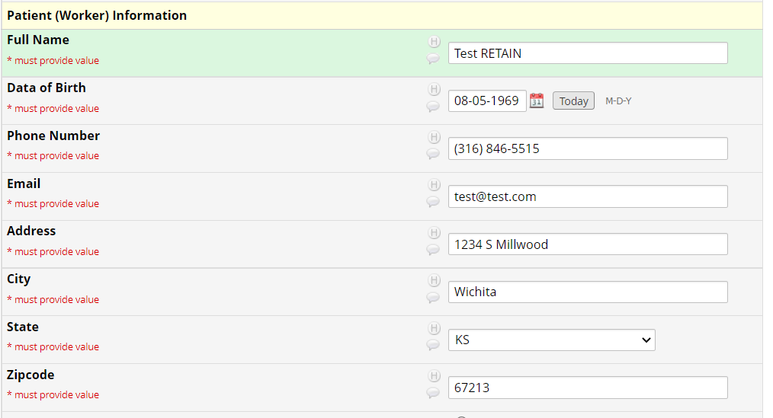

1. As users progress through forms, please note scanned documentation should be uploaded as encountered. To upload, click on “Upload Documentation” and browse for corresponding supporting documentation to attach.
2. Likewise, electronic signatures are available for the providers signatures as shown below:

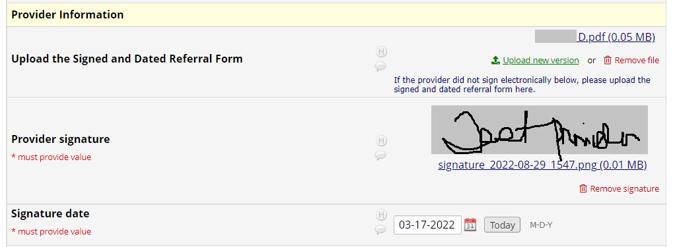

**Step 3: Retrieving an Existing Participant/Patient**

1. From the left menu, data collection section, select :

1. At the Add / Edit Records page, click on the Select Record drop-down list:

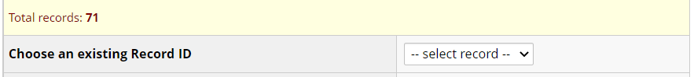

1. Select the desired record.
2. Proceed with instruction from 2.3 above.

**Step 4: Entering Service Providers**

Service Provider section is under construction and will be tied to a drop-down box to complete RTN62. Until construction is complete, we will continue to collect the service provider information manually.

**Step 5: Resources/Help**

Within REDCap, help resources are available on the left menu at the bottom:

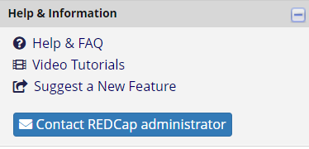

Appendix A is available as a link on section 2.2 of REDCap:



Data collection in REDCap is based on the manual data collection tool as relates to the Appendix A. Data collected in REDCap will allow for the omission of the manual data collection tool and is an abridged version of the total data collected for Appendix A. Dual data entry is still necessary for the purposes of reporting, please continue to enter values in **KANSAS**WORKS.com accordingly.