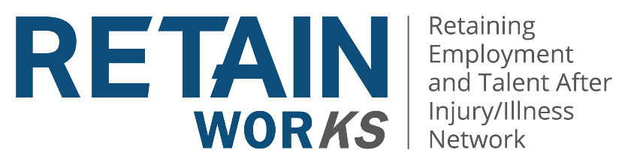

Leadership Team Meeting
Agenda
RETAINWORKS Leadership Team
June 21, 2022, 8:30 – 10:00 AM
Microsoft Teams

- 8:30 AM Roll Call
- Announcements/Updates
- Organizational Updates (Timeline, Staffing, Provider Recruitment, Enrollment)
  - AVC
    - Wichita/LA 4
    - Manhattan/LA 2
    - Pittsburg/LA 5
  - SVH
    - Topeka/LA 2
    - Emporia/LA 5
  - TUKHS/LA 3
  - KCIC/LA 1
- Employer Outreach/Engagement
  - Presentations
  - Equity Goals
  - Website
- Data Collection
  - REDCap update
  - ECHO
- Quarterly Reports – Due July 20th
- Weekly Enrollment Reports (Templates will be provided)
- Expenditure Projections
- Next Meeting August 15, 2022

